CDAC Mumbai
Lab Assignment-1: Flowchart and Java Programming

Name: Mohit Patil | Batch : Aug 2026
Course : Advance Computing | Date Of Submission: 23/08/2026

Instructions:
- For each of the following questions, first create a flowchart to outline the logic.

- After completing the flowchart, write a Java program to implement the logic based on your flowchart.
- Ensure your code follows basic Java syntax and logic.
- You can explore user input (NOT MANDATORY)
Flowchart + Java Program Questions

Check Positive Number:
  - Task: Create a flowchart to check whether a number is positive.
  - Next Step: Write a Java program that checks if a predefined number is positive using an if-else statement and prints the appropriate message.
Sol: Flowchart
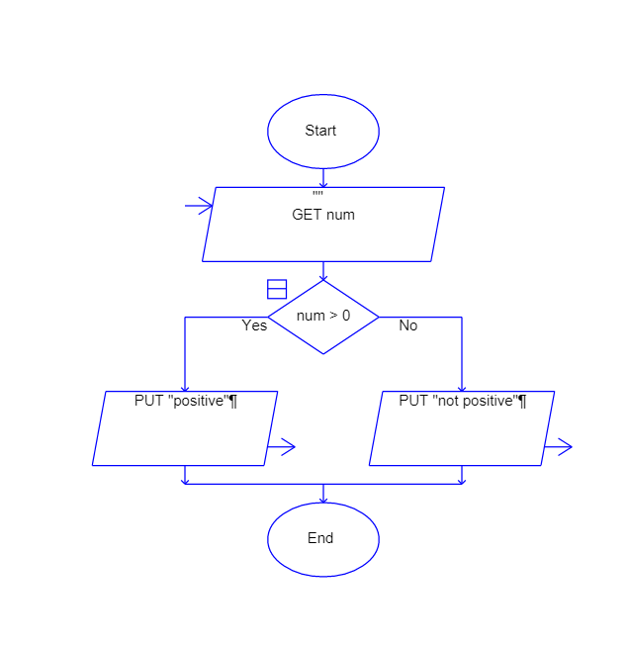
Code:
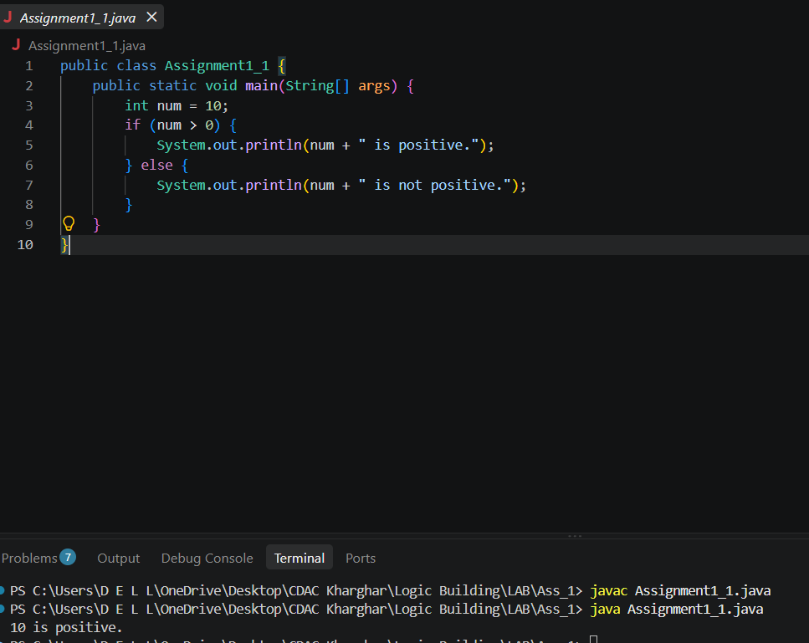

Check Negative Number:
  - Task: Create a flowchart to check whether a number is negative.
  - Next Step: Write a Java program that checks if a predefined number is negative using an if-else statement and displays the result.
Sol: Flowchart
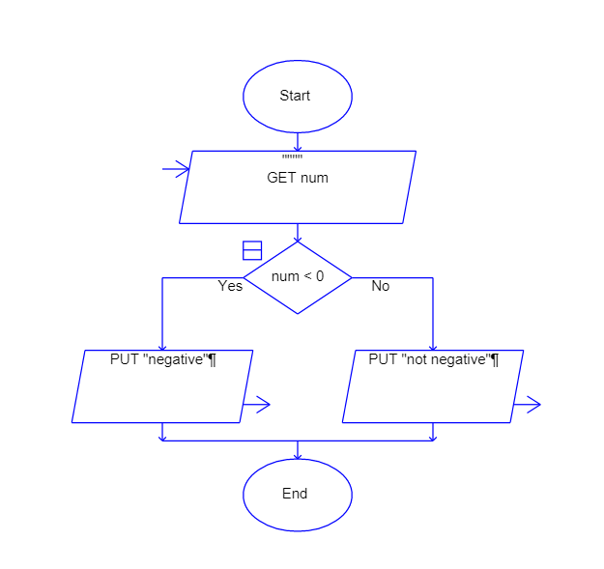
Code:
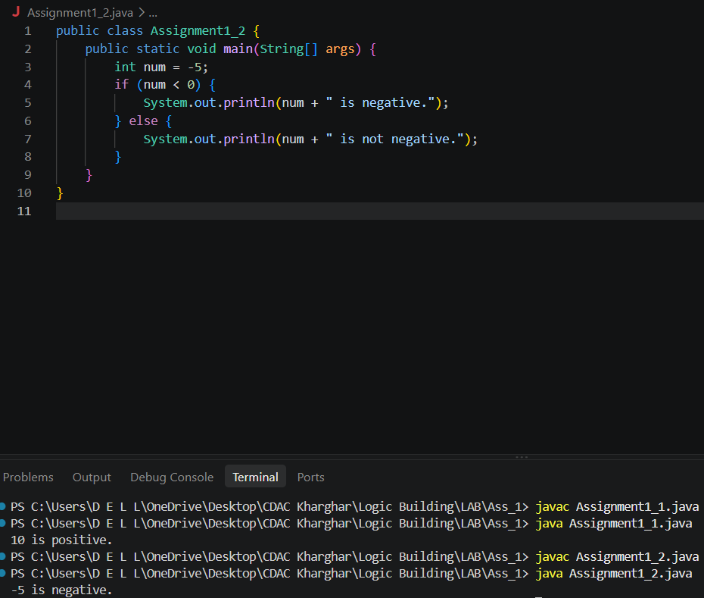

Check Odd or Even Number:
  - Task: Create a flowchart to determine whether a number is odd or even.
  - Next Step: Write a Java program that checks if a predefined number is odd or even. Use an if-else statement and the modulus operator (%) to determine whether the number is divisible by 2 or not.
Sol: Flowchart
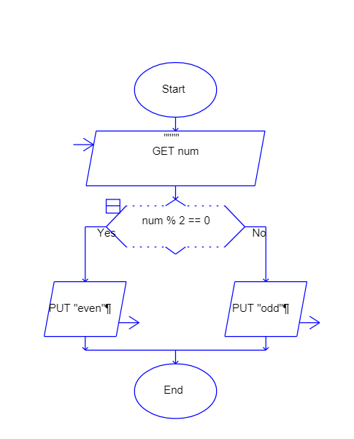
Code:
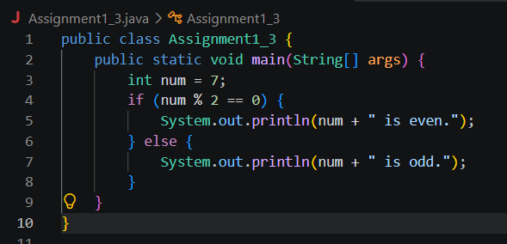

Display Good Morning Message Based on Time:
  - Task: Create a flowchart to display a "Good Morning" message based on a given time.
  - Next Step: Write a Java program that displays a "Good Morning" message if the predefined time is between 5 AM and 12 PM. Use an if statement to implement the logic.
Sol: Flowchart
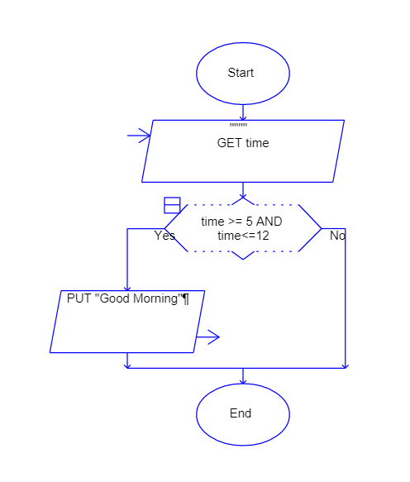
Code:
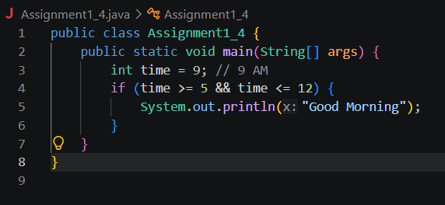

Print Area of a Square:
  - Task: Create a flowchart to calculate and print the area of a square.
  - Next Step: Write a Java program that calculates the area of a square using the formula area = side * side. Use a predefined side length.

Sol: Flowchart

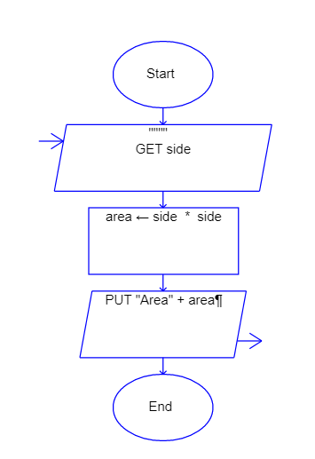
Code:
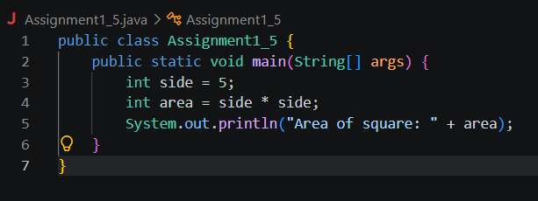

Print Area of a Rectangle:
  - Task: Create a flowchart to calculate and print the area of a rectangle.

  - Next Step: Write a Java program that calculates the area of a rectangle using the formula area = length * width. Use predefined values for length and width.
Sol: Flowchart
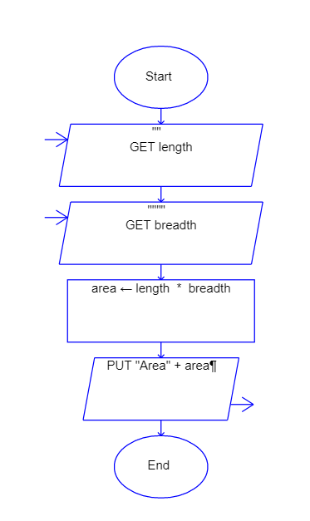
Code:
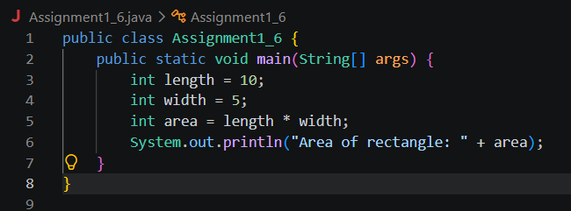

Find the Largest of Three Numbers:
  - Task: Create a flowchart to find the largest of three numbers.
  - Next Step: Write a Java program that finds and prints the largest of three predefined numbers using if-else statements.
Sol: Flowchart
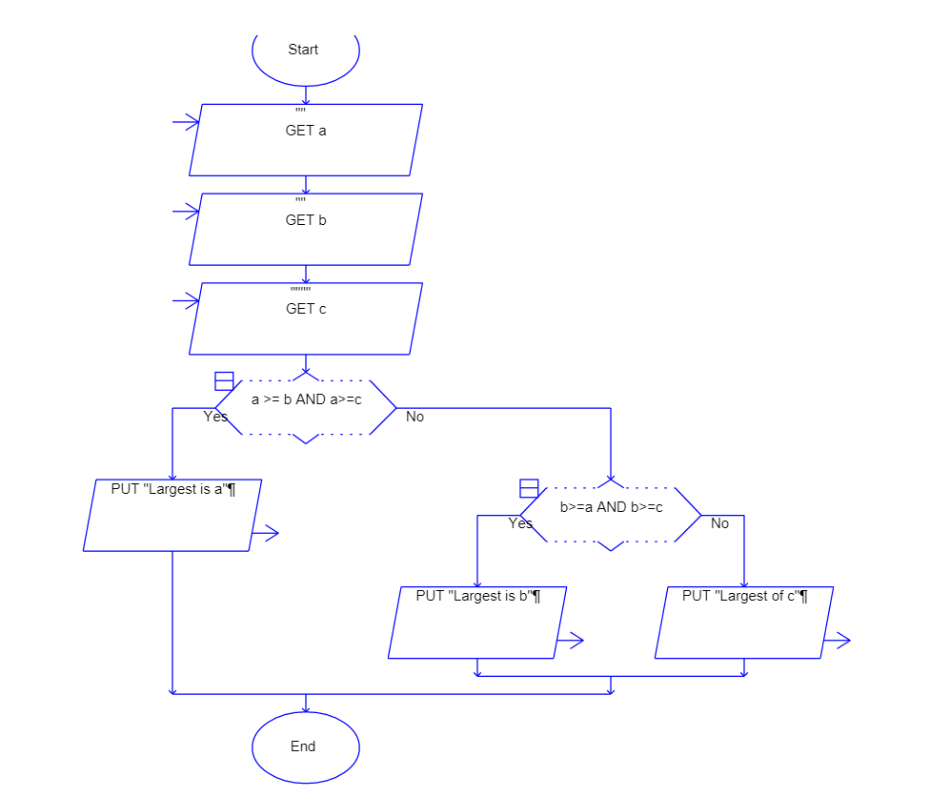
Code:
